PROJECT DEVELOPMENT PHASE (DELIVERY OF SPRINT-2)

|  |  |
| --- | --- |
| **Date** | **10th November 2022** |
| **Project Name** | **Car Resale Value prediction** |
| **Maximum marks** | **4 Marks** |

* 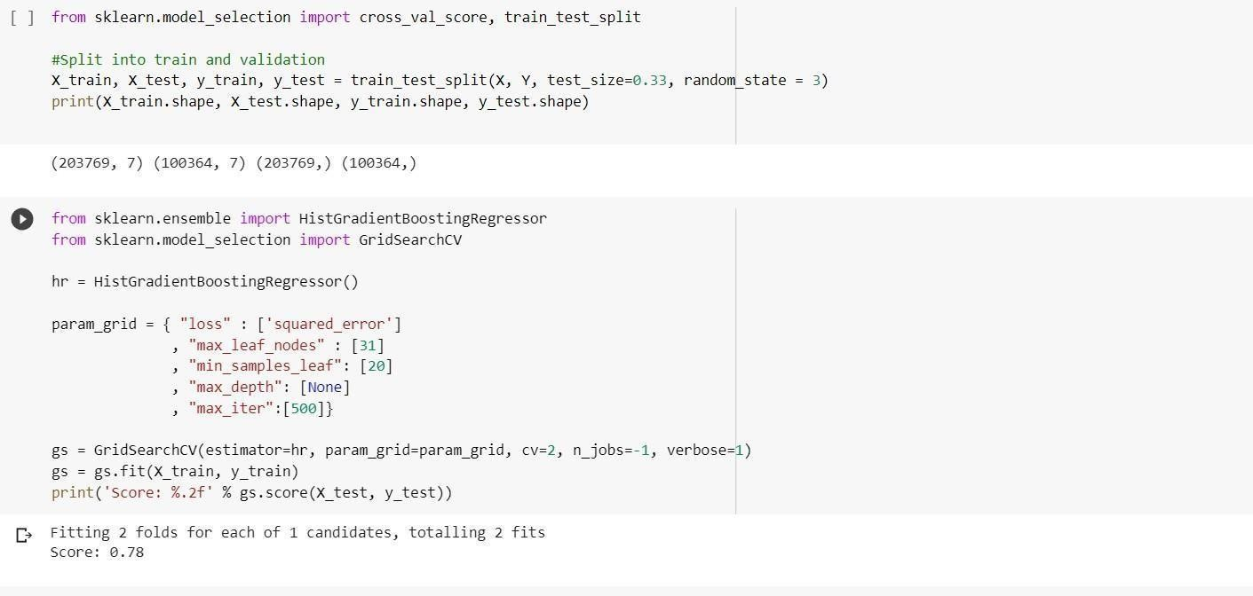**Choosing Appropriate Model:**

Dumping into pickle file:

